**Site Purpose**:

The purpose of this site will be to sell personalized select fruit and grain smoothies, all supplies will be 100% organic with the intention of encouraging health care through nutrition. Also, this page will help people order a smoothie with the fruits they like the most and find out all the nutritional values that they will provide. Lastly, this page will have the purpose of making known the address of our branch and the weather so that they can make a better choice.

**Target Audience**:

My target audience will be parents and the elderly since they are very aware of what they eat and they will be grateful that we give them the facility to personalize their smoothies and know the nutritional value it will bring them, ages may vary but the main audience will be people between 22 – 70 years

**Site Map**:

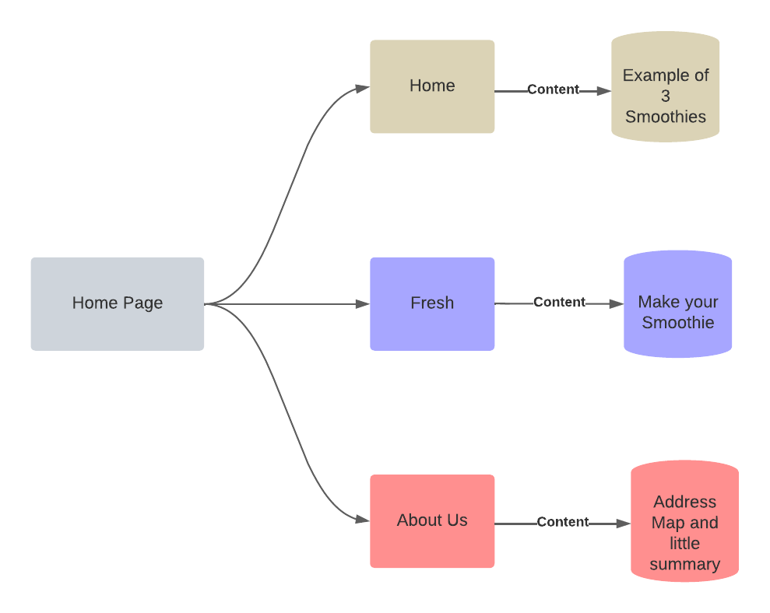

**Color Scheme**:

Since the website will be focused on smoothies and the variety of fruits, I want the colors to be bright colors, colors found in fresh fruits.

**Typography:**

**Tittles and subtitles = Fanwood Text**

**This is an Example of a Title**

**Paragraph = IBM Plex Serif**

This is how a paragraph written with the IBM Plex Serif Font would look like, this is how a paragraph written with the IBM Plex Serif Font would look like. This is how a paragraph written with the IBM Plex Serif Font would look. This is how a paragraph written with the IBM Plex Serif Font would look.

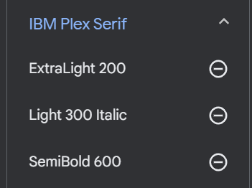

Link:

<style> @import url('https://fonts.googleapis.com/css2?family=Fanwood+Text:ital@0;1&family=IBM+Plex+Serif:ital,wght@0,200;0,600;1,300&display=swap'); </style>

1. font-family: 'Fanwood Text', serif;
2. font-family: 'IBM Plex Serif', serif;

**Wireframe Sketches:**

Large Monitors

Home Page Fresh Page

About Us

Home Page – Medium Screen

Home Page - Small Screen

